**Appointment service Use Cases**

1. **Creating Appointment**

**Post Method : http://localhost:8080/createAppointment**

PayLoad :

{

"dcNumber": "7013",

"appointmentDate": "2020-10-21",

"truckNumber": 124,

"pos": [

{

"poNbr": "12345678",

"qty": 10

},

{

"poNbr": "0123445",

"qty": 6

}

]

}

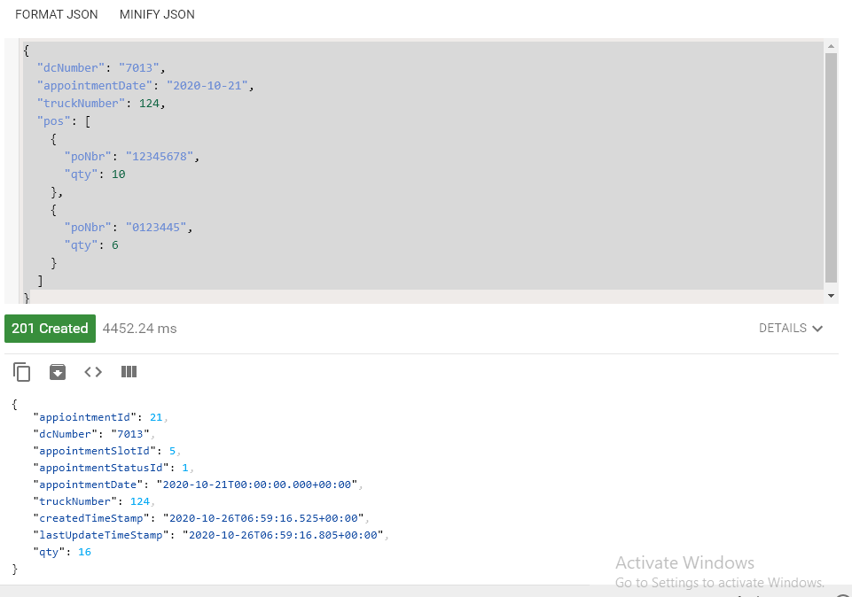

Appointment Id 21 consumed by consumer:

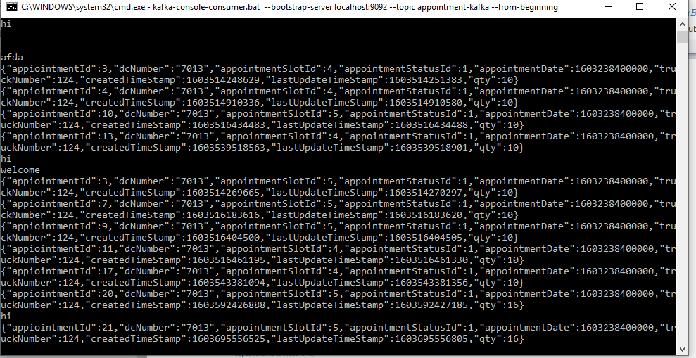

**2. Update Appointment :**

**Put method http://localhost:8080/updateAppointment/21**

{

"dcNumber": "7013",

"appointmentDate": "2020-10-21",

"truckNumber": 124,

"pos": [

{

"poNbr": "12345678",

"qty": 10

},

{

"poNbr": "0123445",

"qty": 5

}

]

}

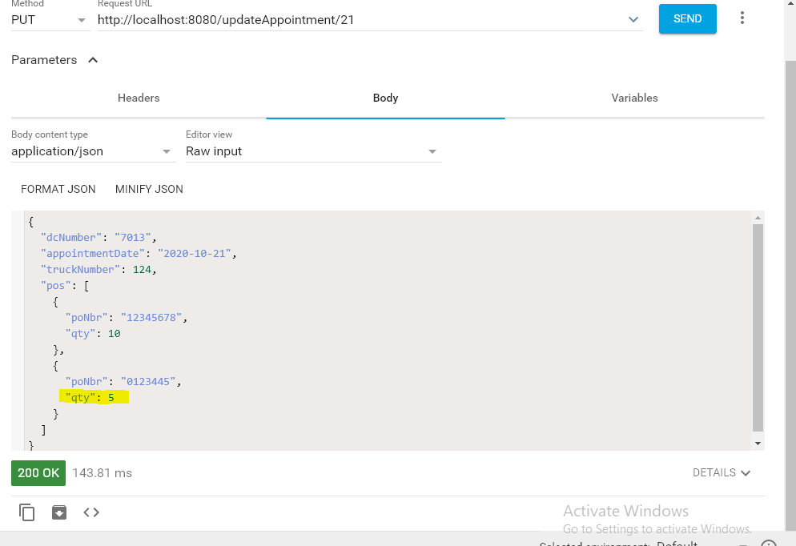

Total Quantity is updated in Appointment table

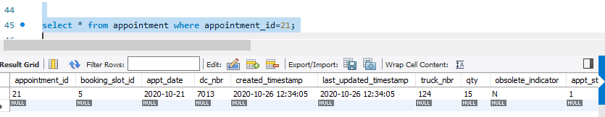

**3. Search All appointment:**

**GET method : http://localhost:8080/getAllAppointment**

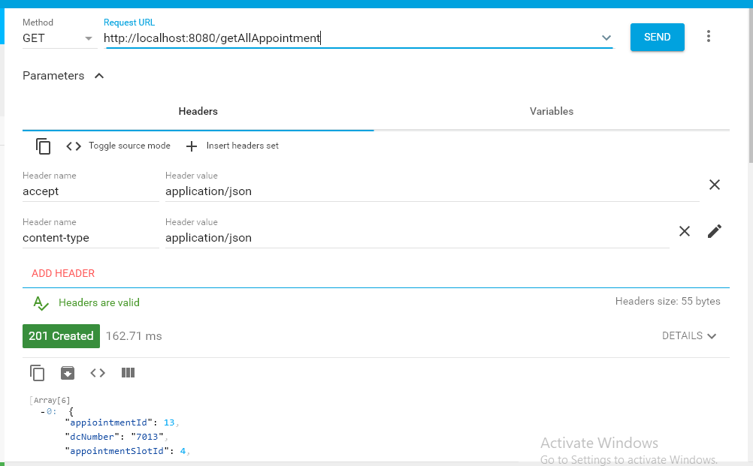

Response :

  {

"appiointmentId": 13,

"dcNumber": "7013",

"appointmentSlotId": 4,

"appointmentStatusId": 1,

"appointmentDate": "2020-10-20T18:30:00.000+00:00",

"truckNumber": 124,

"createdTimeStamp": "2020-10-24T11:38:39.000+00:00",

"lastUpdateTimeStamp": "2020-10-24T11:38:39.000+00:00",

"qty": 10

},

  {

"appiointmentId": 16,

"dcNumber": "7013",

"appointmentSlotId": 4,

"appointmentStatusId": 1,

"appointmentDate": "2020-10-20T18:30:00.000+00:00",

"truckNumber": 124,

"createdTimeStamp": "2020-10-24T11:40:50.000+00:00",

"lastUpdateTimeStamp": "2020-10-24T11:40:52.000+00:00",

"qty": 10

}

4. Deleting appointment:

Appointment Table entry before deleting appointment

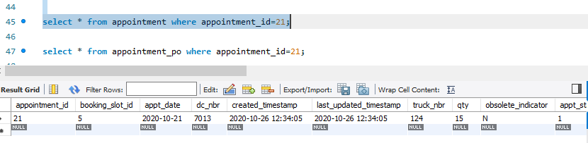

Records in appointment_po table

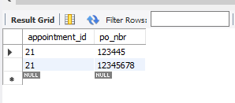

**Delete Method : http://localhost:8080/delete/21**

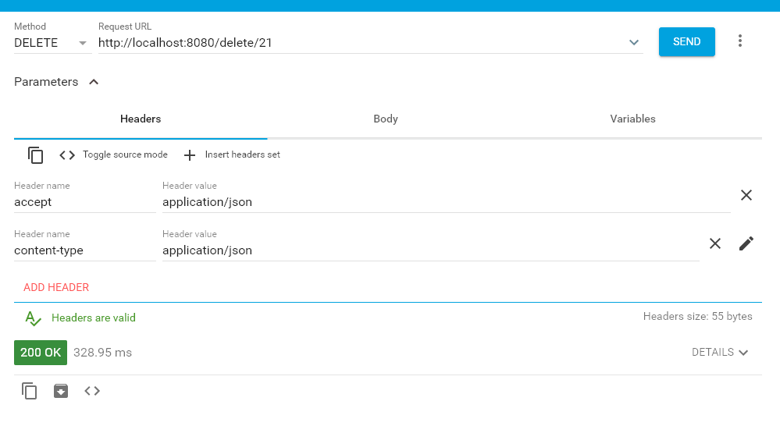

Appointment table entries removed

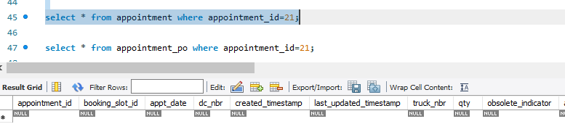

Appointment_po entries relate to appointment

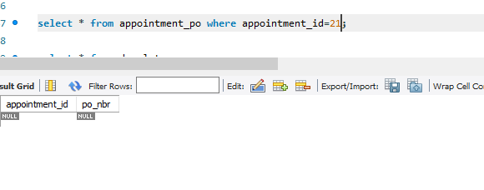

‘

**5.If maximum truck count reached for the slot it will through exception “maximum truck count reached”**

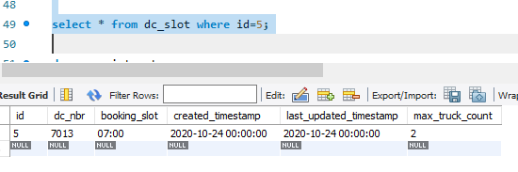

**Total appointment booked for the slot is 2**

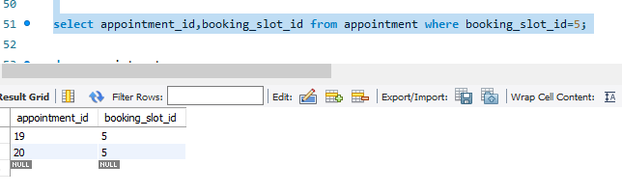

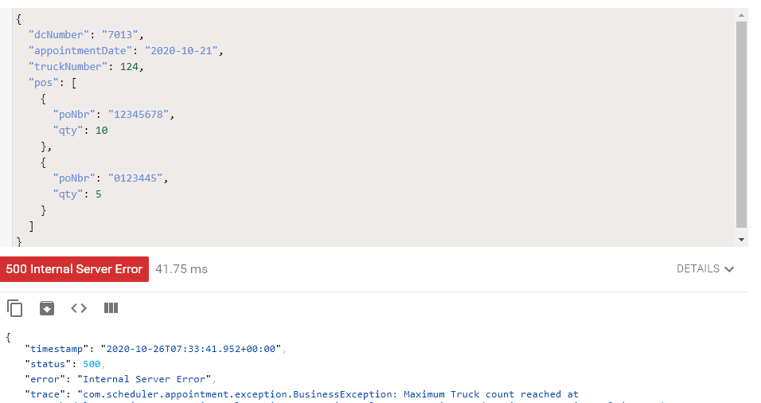

**6. Appointment sending to third party system:**

Appointment Id 21 consumed by consumer:

